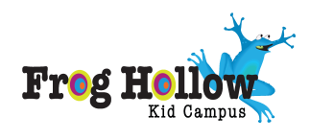North Liberty Community Activities

North Liberty Blues & BBQ, presented by South Slope Cooperative Communications. Join us July 12, 2014, for live blues, great food, and good times.
Iowa City Jazz Festival -- Moving to Thursday - Saturday, July 3-5, and featuring HUGE names like Joe Lovano and Tom Harrell. The Iowa City fireworks will take place Saturday, July 5
Coralville's annual 4th of July celebration is a community tradition that attracts thousands of visitors and residents each year. The multi-day event includes a 5K run / walk, entertainment, food, free concerts, a carnival, parade, and fireworks. Celebrate on June 28, & July 3-6, 2014. Most events are free and take place in S.T. Morrison Park, located in the 1500 block between 7th and 8th Streets.
Park It at the Movies: Coralville offers an outdoor family movie night each summer. Bring lawn chairs, blankets, and snacks and enjoy a free movie night under the stars at a neighborhood park. They will be showing Despicable Me 2 Friday, July 18 Start time: approximately 9:00 pm. Location: S.T. Morrison Park (1500 block between 7th and 8th Streets)

